Parametric Functions – Teaching Set 3
Cover topics ….
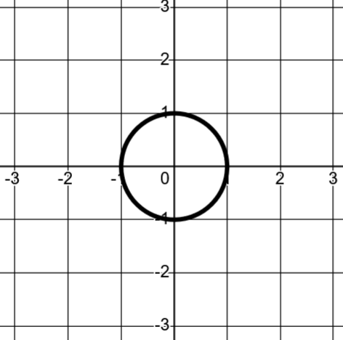
A circular motion (radius 1) around the origin is:
$x\left(t\right)=cos(t)$ $y\left(t\right)=sin⁡(t)$
Let’s experiment with transforming these equations to create transformed paths.
1). [C] Discover ways to transform a circular path
For each goal, make an educated guess about how to do it (based on your understanding of how these equations work). Then you can check/experiment on Desmos.
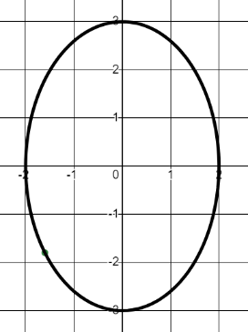
a). Make a circular motion around the origin but for a larger circle (say, radius 3).
b). Make a circular motion for a radius 3 circle, but centered at (2, 3)
c). Make a motion shaped like an ellipse (say, this one)
d). Make the circular motion go the other direction (clockwise instead of anti-clockwise)

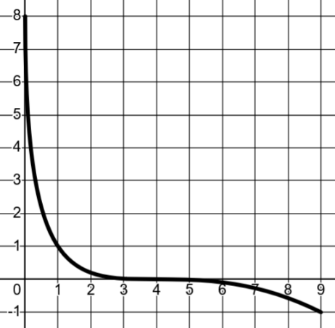
2). [C] Here’s the path determined by:
$x\left(t\right)={\left(t-3\right)}^{2}$ and $y\left(t\right)={\left(t-1\right)}^{3}$ for $0≤t≤3$
What should the path look like for each of the following?
a). $x\left(t\right)=-{\left(t-3\right)}^{2}$ and $y\left(t\right)={\left(t-1\right)}^{3}$
b). $x\left(t\right)={\left(t-3\right)}^{2}$ and $y\left(t\right)={\left(t-1\right)}^{3}-1$
c). $x\left(t\right)={\left(t-3\right)}^{2}$ and $y\left(t\right)=8-{\left(t-1\right)}^{3}$

3). [C] How can you shift the timing only?
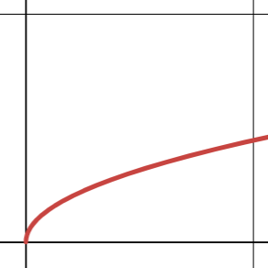

In other words, if you have some parametric equations describing
t = 1
t = 4
X
Y
4
1
t = 26
t = 29
X
Y
4
1
this… how can we make THIS ?

The equations $x\left(t\right)=t$ and $y\left(t\right)=\sqrt{t}$ match the path on the left (how could you check this was true?)
a. Create a new set of equations $x(t)$ and $y(t)$ that fit the picture on the right as if you were doing it from scratch.
Now let’s think about how you could transform the first set to become the second set.

b. Take your $x(t)$ equation from part a. What transformation does $x(t-1)$ represent?
How does it change the $x(t)$ graph? What does that change about the movement?

c. Say we take your $x(t)$ and $y(t)$ from part a and write two new equations: $x(t-1)$ and $y(t-1)$
Is it still a square root path? What’s the timing information for when it’s at (1, 1) and (4, 2)?

d. Create a new set of equations $x(t)$ and $y(t)$ that would fit this picture…
t = 8
t = 3
X
Y
4
1

4). [C] How can you change the speed of the movement?

Our goal is to figure out how we can take a set of parametric equations such as the ones to the right, and modify them so the point moves faster.
t = 3
X
Y
1
$$x\left(t\right)=t-2$$
$$y\left(t\right)=\sqrt{t-2}$$
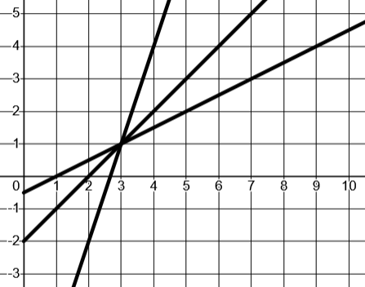
a). First, consider these different $x(t)$ graphs.
t
x(t)
Which will make the point move fastest? Slowest?

b). Let’s take the fastest one and use it as the $x(t)$ equation for the path $y=\sqrt{x}$. That gives $x\left(t\right)=3\left(t-3\right)+1$ and $y\left(t\right)=\sqrt{3\left(t-3\right)+1}$ . Say x is in feet and t is in seconds. What’s the horizontal speed (in ft/sec) of this motion?
c). The horizontal speed isn’t the same as what we would just call its speed of movement overall. For example, if the point were a car that we clocked with a speedometer, why wouldn’t its speed by 3 $ft/sec$ ? What can you say about the speed?

d). Let’s slow it waaaay down. Create an $x(t)$ and $y(t)$ to fit this picture.
t = 1
t = 33
X
Y
4
1

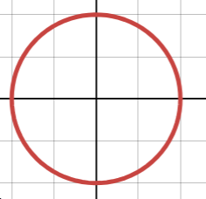
5). [C] The goal of this problem is to think about how making an equation for the angle at different times will let you change the movement.
X
Y
t = 0
$$x\left(t\right)=\cos\left(t\right)$$
$$y\left(t\right)=sin⁡(t)$$
Key idea.
Let’s ONLY change how the angle moves as a function of time.

$$x\left(t\right)=\cos\left( \right)$$
$$y\left(t\right)=\sin\left( \right)$$
The key idea is that we’ll change the inside of the sin(…) and cos(…) functions.
Let’s think about making a function $A(t)$ that gives an angle as a function of time. (Quick sense check: If I say $A\left(4\right)=\frac{π}{3}$ , in practical terms what is that saying?).
We’ll use $A(t)$ as the angle for the sine and cosine functions, like this:
Let A(t) = …..?
$$x\left(t\right)=cos⁡( A\left(t\right) )$$
$$y\left(t\right)=sin⁡( A\left(t\right) )$$

Let’s play around with different $A(t)$ functions to see what they’ll do.
a). For each $A(t)$ graph below, think about the path formed by $x\left(t\right)=\cos\left( A\left(t\right) \right)$ and $y\left(t\right)=\sin\left(A\left(t\right)\right)$.
- Predict what the movement of the point should be on the circle just by looking at the angle graph.
- Sketch the circular path. Show where $t=0$ is on the circle. Use arrows to show the direction of motion.
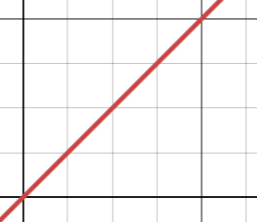  t  A(t)  0  4  0  $$2π$$ | 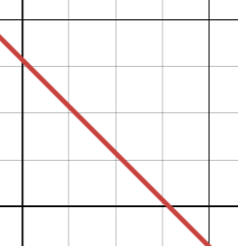  t  A(t)  0  $$6$$  $$\frac{π}{2}$$  0 | 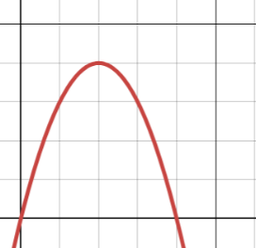  0  10  $$\frac{π}{2}$$  A(t)

b). For each $A(t)$ equation above, write the equation for A(t). Write the full equations for $x(t)$ and $y(t)$. Use these to test the movements in desmos.

Parametric Functions – Teaching Set 3 – Solutions
1). [C] Discover ways to transform a circular path
For each goal, make an educated guess about how to do it (based on your understanding of how these equations work). Then you can check/experiment on Desmos.
a). Make a circular motion around the origin but for a larger circle (say, radius 3).
One way to think about this is that $x\left(t\right)=cos⁡(t)$ can only output x coordinates between -1 and 1, since those are the smallest and largest outputs from the cosine functions. Similarly for $y\left(t\right)=sin⁡(t)$.
A radius 3 circle should output x and y coordinates between -3 and 3. To get this we can scale sine and cosine by 3: $x\left(t\right)=3\cos\left(t\right)$ and $y\left(t\right)=3\sin\left(t\right)$.
Notice that if the equations had been something else, like $x\left(t\right)=3t^{2}-2t$ and $y\left(t\right)=\frac{1}{t-5}$ , scaling x and y would also dilate this path. $x\left(t\right)=3\left(3t^{2}-2t\right)$ and $y\left(t\right)=3\left(\frac{1}{t-5}\right)$ would represent the same path but dilated out from the origin by a factor of 3.
b). Make a circular motion for a radius 3 circle, but centered at (2, 3)
Here, we can shift the x and y coordinates instead of dilating them.
$x\left(t\right)=\cos\left(t\right)$ $x\left(t\right)=2+cos⁡(t)$
$y\left(t\right)=sin⁡(t)$ $y\left(t\right)=3+sin⁡(t)$

Test the idea in your mind. $\cos\left(t\right)$ is the old x coordinate. $x\left(t\right)=2+cos⁡(t)$ is like saying: $\left(new x coordinate\right)=2+(old x coordinate)$

c). Make a motion shaped like an ellipse (say, this one).
Here we just dilate x and y by different amounts:
$x\left(t\right)=2⋅cos⁡(t)$
$y\left(t\right)=3⋅sin⁡(t)$
d). Make the circular motion go the other direction (clockwise instead of anti-clockwise)
There are two nice ways to think about this.
Idea 1: If we reflect only the y coordinates what used to be anit-clockwise movement becomes clockwise movement. (think about this!)
$x\left(t\right)=cos⁡(t)$ and $y\left(t\right)=-sin⁡(t)$
Idea 2: If time were to run backwards, then the motion would also go backwards, so anti-clockwise movement would become clockwise.
$x\left(t\right)=cos⁡(-t)$ and $y\left(t\right)=sin⁡(-t)$
Both ideas work fine! As usual, don’t settle on your favorite idea and forget the other one. Both ways of thinking will be useful, and we’ll use both.

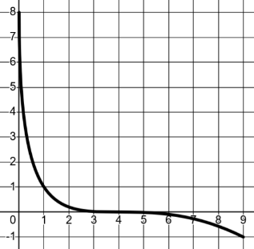
2). [C] Here’s the path determined by:
$x\left(t\right)={\left(t-3\right)}^{2}$ and $y\left(t\right)={\left(t-1\right)}^{3}$ for $0≤t≤3$
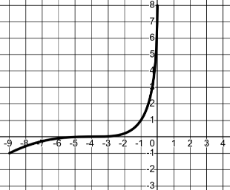
What should the path look like for each of the following?
a). $x\left(t\right)=-{\left(t-3\right)}^{2}$ and $y\left(t\right)={\left(t-1\right)}^{3}$
Here we’ve reflected just the x coordinates.

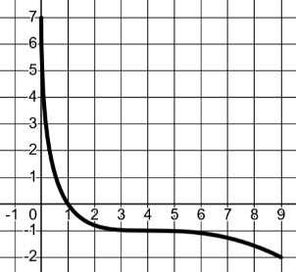
b). $x\left(t\right)={\left(t-3\right)}^{2}$ and $y\left(t\right)={\left(t-1\right)}^{3}-1$
Here we’ve subtracted 1 from the y coordinates

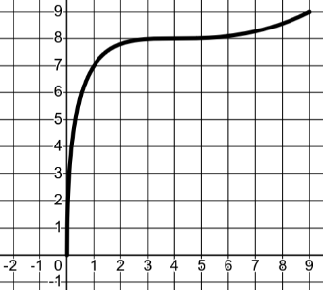
c). $x\left(t\right)={\left(t-3\right)}^{2}$ and $y\left(t\right)=8-{\left(t-1\right)}^{3}$
reflect shift up
Here we’ve reflected the y coordinates and shifted them up by 8.
To see this more clearly, think $y\left(t\right)=8-{\left(t-1\right)}^{3}$ is the same as $y\left(t\right)=-{\left(t-1\right)}^{3}+8$


3). [C] The equations $x\left(t\right)=t$ and $y\left(t\right)=\sqrt{t}$ match the path on the left. How can you check if that’s true?
t = 1
t = 4
X
Y
4
1
Check the path. Find the cartesian equation for the path. Substitute: $x=t$ into the $y(t)$ equation to get $y=\sqrt{x}$. Certainly that seems to fit the picture.

Check the timing. If t = 1, then x = 1 and y = 1. That fits.
If t = 4, x = 4 and y = 2. That fits too.


a. Create a new set of equations $x(t)$ and $y(t)$ that fit the picture on the right.
t = 26
t = 29
X
Y
4
1

The big idea is to sketch a $x(t)$ that fits the times and the x positions.

Now write an equation for the line.
Slope: $\frac{3}{3}=1$
$$x\left(t\right)=1⋅\left(t-26\right)+1$$
$x\left(t\right)=t-25$

Once you have an $x(t)$ that does what you need, you can use it in $y=\sqrt{x}$ to ensure the point will also follow the path you want. So: $x\left(t\right)=t-25$ and $y\left(t\right)=\sqrt{t-25}$

b. Take your $x(t)$ equation from part a.
What transformation does $x(t-1)$ represent? Shift right by 1.

How does it change the $x(t)$ graph? It changes the timing to be later by 1 second, because the horizontal axis of $x(t)$ is the time axis.

c. Say we take your $x(t)$ and $y(t)$ from part a and write two new equations:
$x(t-1)$ and $y(t-1)$

Is it still a square root path? It should be if all we shifted was time. Let’s check.

$x\left(t-1\right)=t-26$ and y$\left(t-1\right)=\sqrt{t-26}$
t = 27
t = 30
X
Y
4
1
Substituting still gives $y=\sqrt{x}$

What’s the timing information for when it’s at (1, 1) and (4, 2)?
1 second later, as you discovered in part b.

d. Create a new set of equations $x(t)$ and $y(t)$ that would fit this picture…


For the x(t) graph we have
t = 8
t = 3
X
Y
4
1
Slope: $-\frac{3}{5}$
$$x\left(t\right)=-\frac{3}{5}\left(t-3\right)+4$$
$$y\left(t\right)=\sqrt{-\frac{3}{5}\left(t-3\right)+4}$$


4) [C]
t
x(t)
a). Consider these different $x(t)$ graphs.

Which will make the point move fastest?
The one with the steepest slope will move fastest. Think about this. Slope is $\frac{rise}{run}$ . For us $rise$ represents change in x. $run$ represents change in time. So $\frac{rise}{run}=\frac{change in x}{change in time}$ . That’s (horizontal) speed! If x is measured in ft and time is measured in seconds, the slope would have units of $ft/sec$.

Slowest? The one with the shallowest slope for the same reason.

b). Let’s take the fastest one. It has the movement:
$x\left(t\right)=3\left(t-3\right)+1$
$y\left(t\right)=\sqrt{3\left(t-3\right)+1}$ .

Say x is in feet and t is in seconds. What’s the horizontal speed (in ft/sec) of this motion? $3 ft/sec$ It’s just the slope of the line in the $x(t)$ function.
c). If we were to clock the moving point with a speedometer, why wouldn’t its speed by 3 $ft/sec$ ?
Because $3 ft/sec$ is how fast the horizontal position changes. But it’s actually moving along a square root path, so the vertical position is also changing. In 1 second it moves 3 feet to the right, but some additional distance up. Therefore the overall (average) speed would be the total distance travelled in that 1 second, but that depends on how far it went up in that second.
We can’t actually give a single numeric answer for the speed because the amount it’s going up each second changes because of the curve of the square root graph. Think about this question: Do you think the average speed between t = 0 and t = 1 is faster or slower than the average speed from t = 10 to t = 11 ?
d). Let’s slow it waaaay down.
Create an $x(t)$ and $y(t)$ to fit this picture.

Slope: $\frac{3}{32}$
$$x\left(t\right)=\frac{3}{32}\left(t-1\right)+1$$
$$y\left(t\right)=\sqrt{\frac{3}{32}\left(t-1\right)+1}$$

t = 1
t = 33
X
Y
4
1

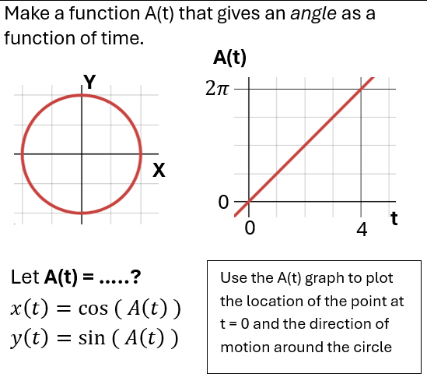
5). [C]
Here you can see at t = 0 we want an angle of 0.
But at t = 4 we have an angle of $2π$ (which is $360°$).

$A\left(t\right)=\frac{π}{2}t$ so $x\left(t\right)=\cos\left(\frac{π}{2}t\right)$ and $y\left(t\right)=\sin\left(\frac{π}{2}t\right)$
$$A\left(t\right)=\frac{π}{2}t$$

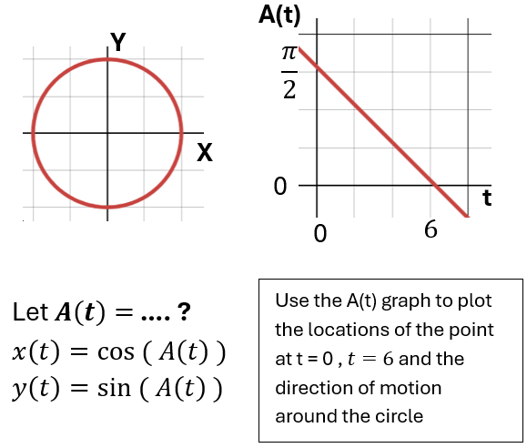
slope is $-\frac{\frac{π}{2}}{6}→-\frac{π}{12}$
$A\left(t\right)=-\frac{π}{12}t+\frac{π}{2}$ so..
$x\left(t\right)=\cos\left(-\frac{π}{12}t+\frac{π}{2}\right)$ and $y\left(t\right)=\sin\left(-\frac{π}{12}t+\frac{π}{2}\right)$

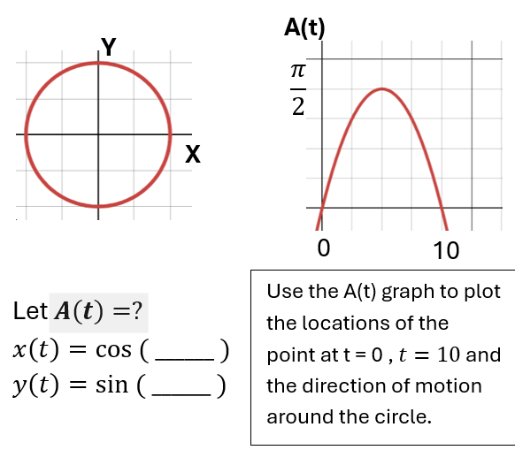
Upside down parabola shifted right by 5 and up by $\frac{π}{2}$. BUT we need to vertically scale it so it goes through (0, 0).

$A=-k⋅{\left(t-5\right)}^{2}+\frac{π}{2}$ $0=-25⋅k+\frac{π}{2}$ $k=\frac{π}{50}$
So $A\left(t\right)=-\frac{π}{50}{\left(t-5\right)}^{2}+\frac{π}{2}$ .

The movement is to start at the right side of the circle, rotate counter-clowise to the top and then go back.

